LOGIN Page

The login page provides secure access to the system through user authentication. It validates credentials and prevents unauthorized entry.

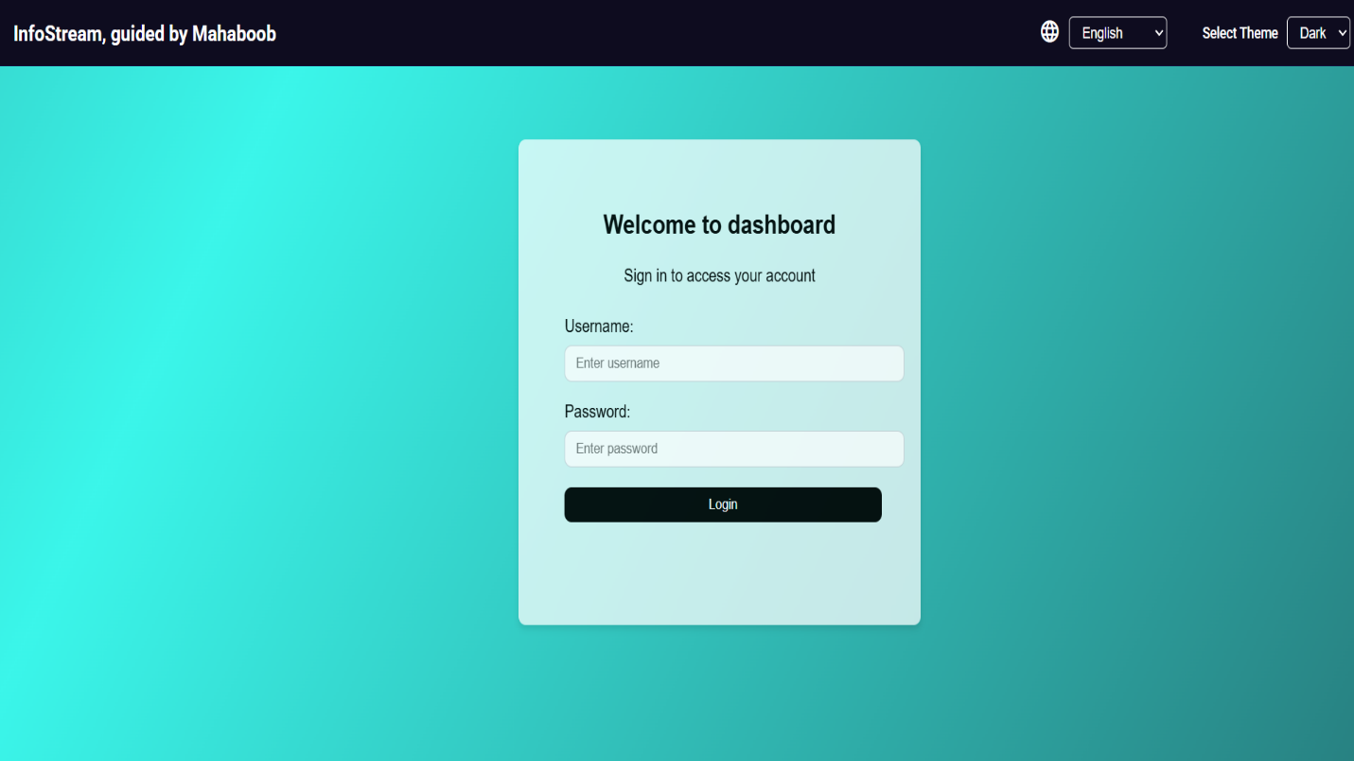

Genai Integration

The project integrates Generative AI to enhance user interaction and automate certain tasks. This improves efficiency and provides intelligent responses.

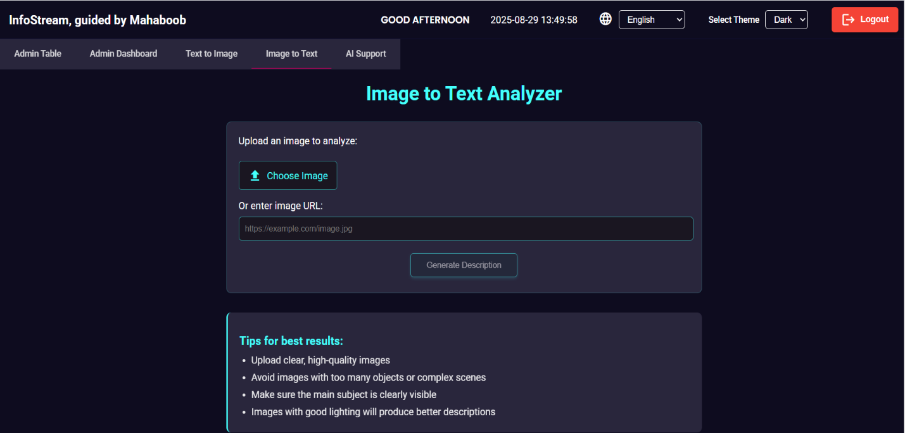

Admin dashboard

The dashboard gives administrators a centralized view of system activities, user statistics, and key controls. It streamlines management and monitoring.

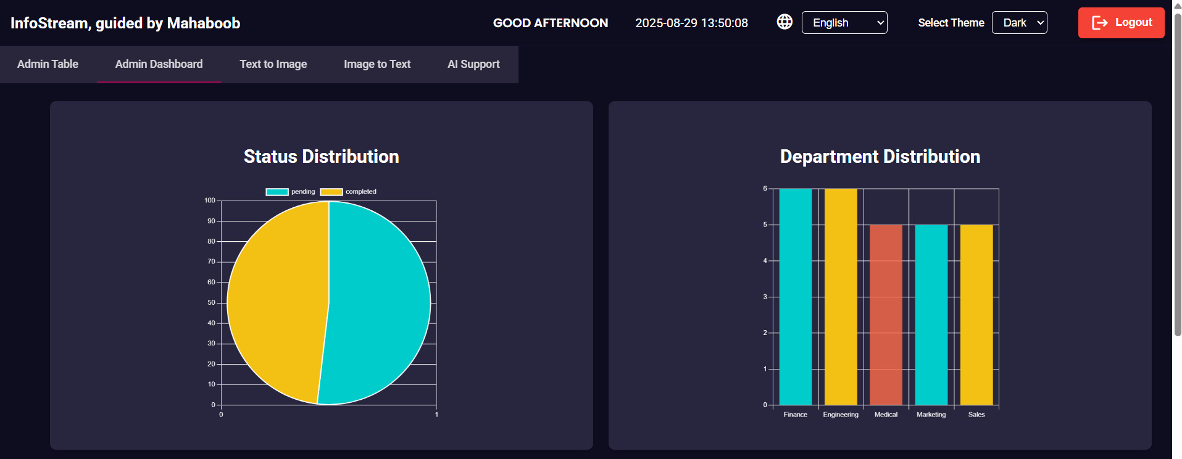

User Table

The user table displays a structured list of registered users with their details. It supports actions like view, edit, and delete for user management.

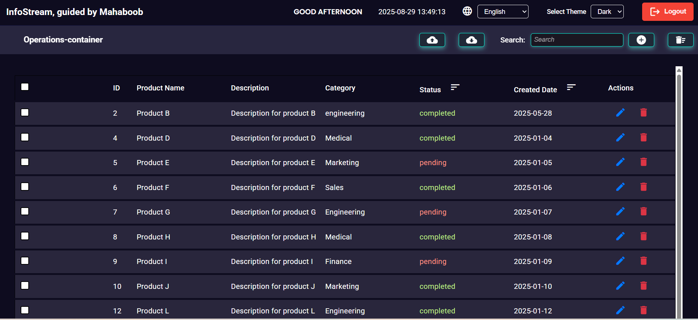

Add User

This feature allows administrators to add new users into the system by filling in the required details. It ensures proper onboarding and access control.

